**16-720 Computer Vision: Homework 5 (Fall 2022)**

**Neural Networks for Recognition**

Haejoon Lee

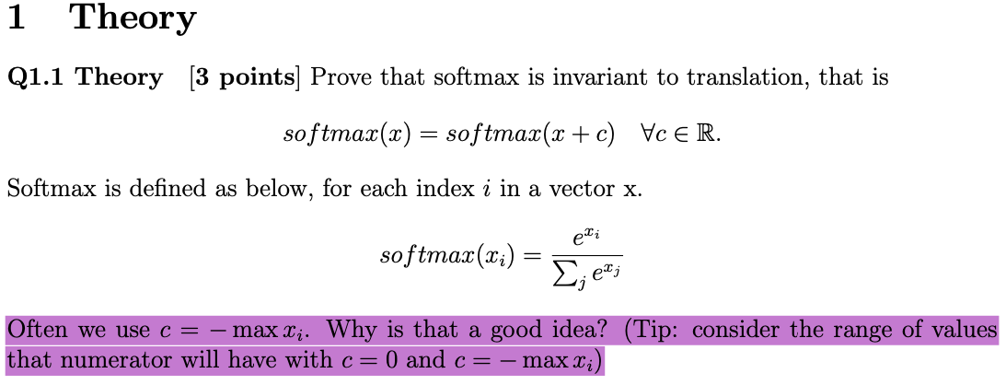

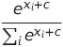 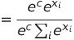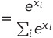

Thus, softmax is invariant to translation.

By use -max(xi), we can confine the range of numerator to from 0 to 1 to prevent overflow.

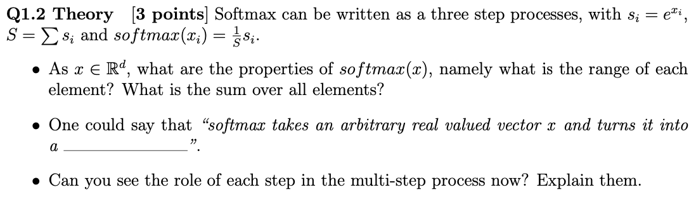

1. Range of each element: 0~1, sum over all elements: 1
2. “Probability score”
3. First, map x_i to positive. Then, sum all for the next step. Lastly, divide s_i over the sum to calculate probability.



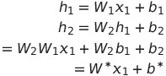



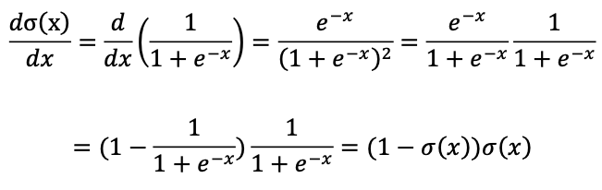

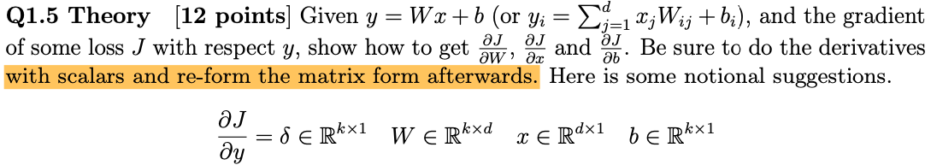

1)

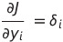

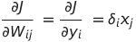

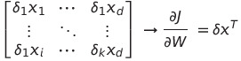

2)

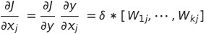

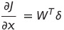

3)

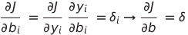

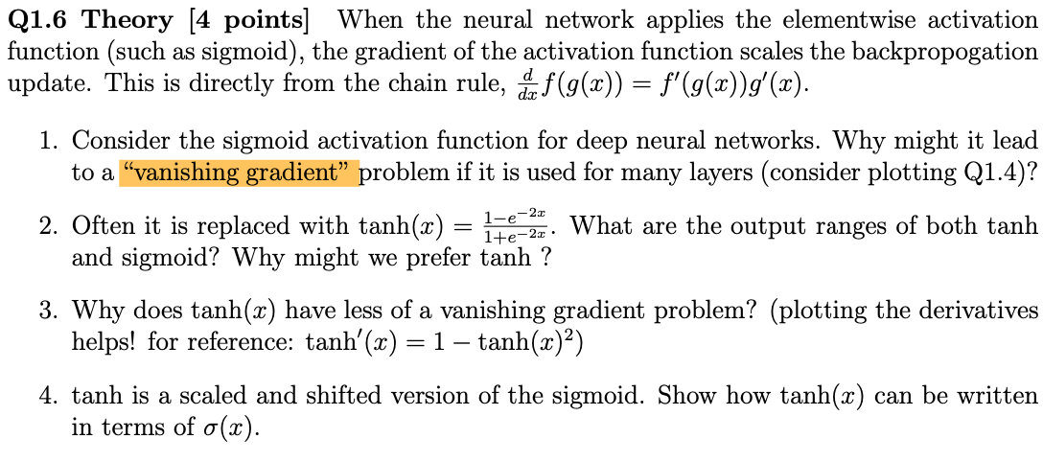

1)

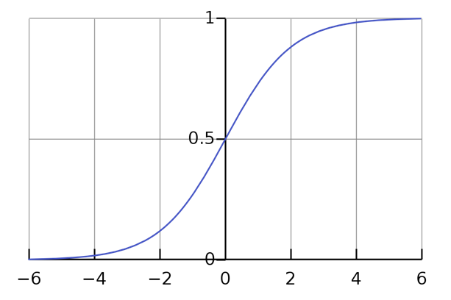

When the input for sigmoid goes to big positive or negative value, the gradient of the function approach to zero.

2)

Sigmoid: 0 ~ 1

Tanh: -1 ~ 1

Since the Tanh is zero-centered, it can produce minus (-) gradient values for weight update.

3)

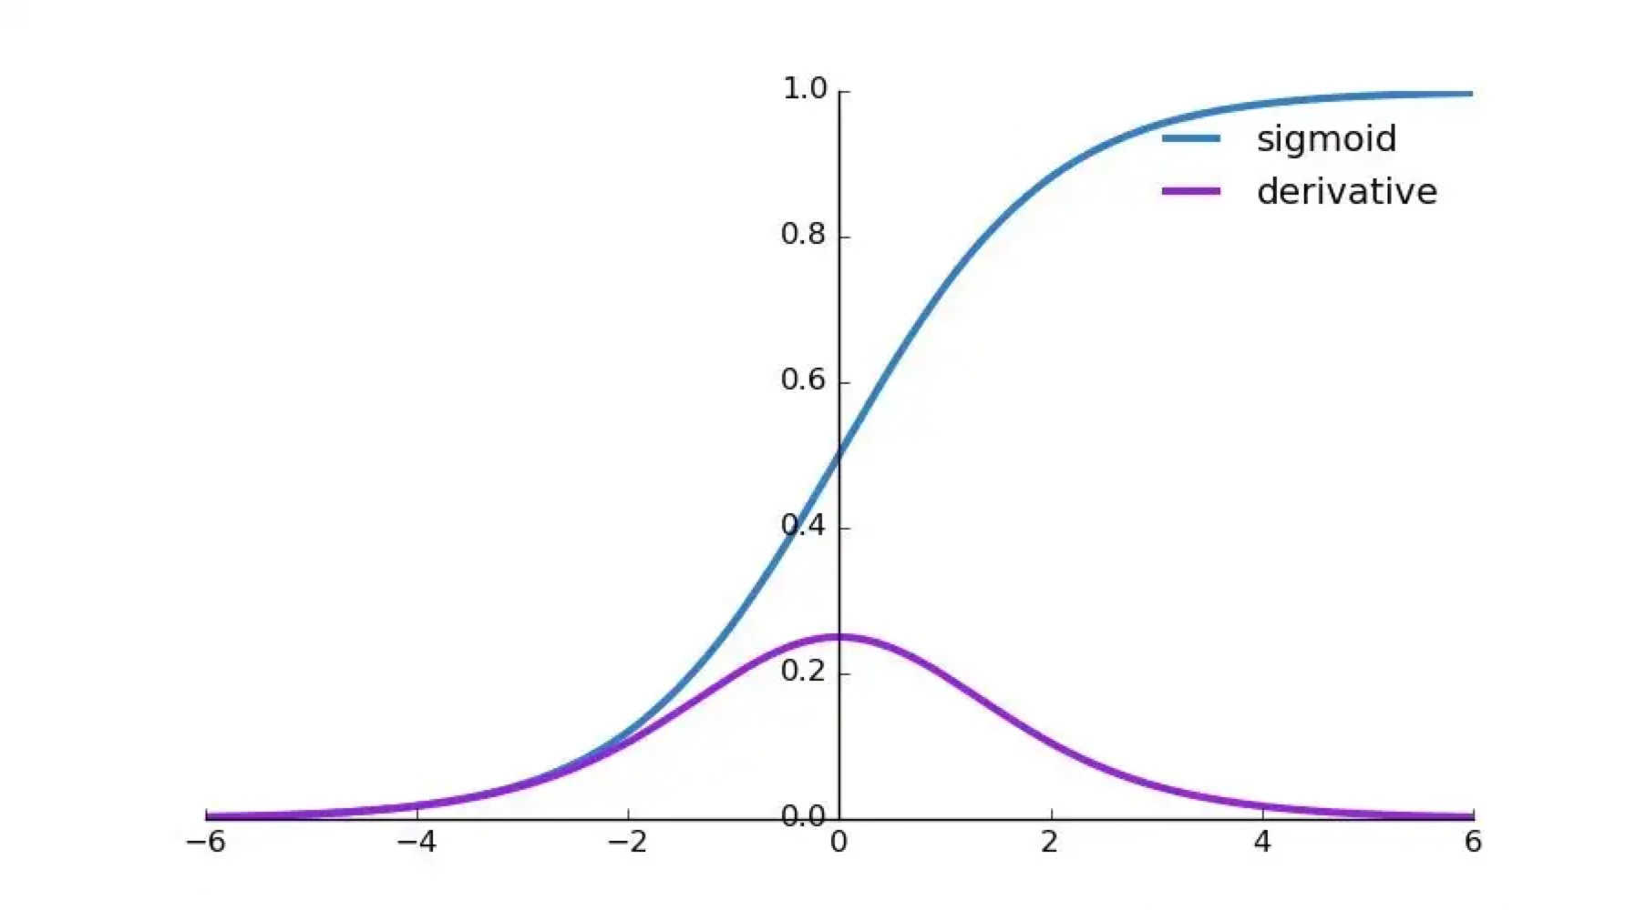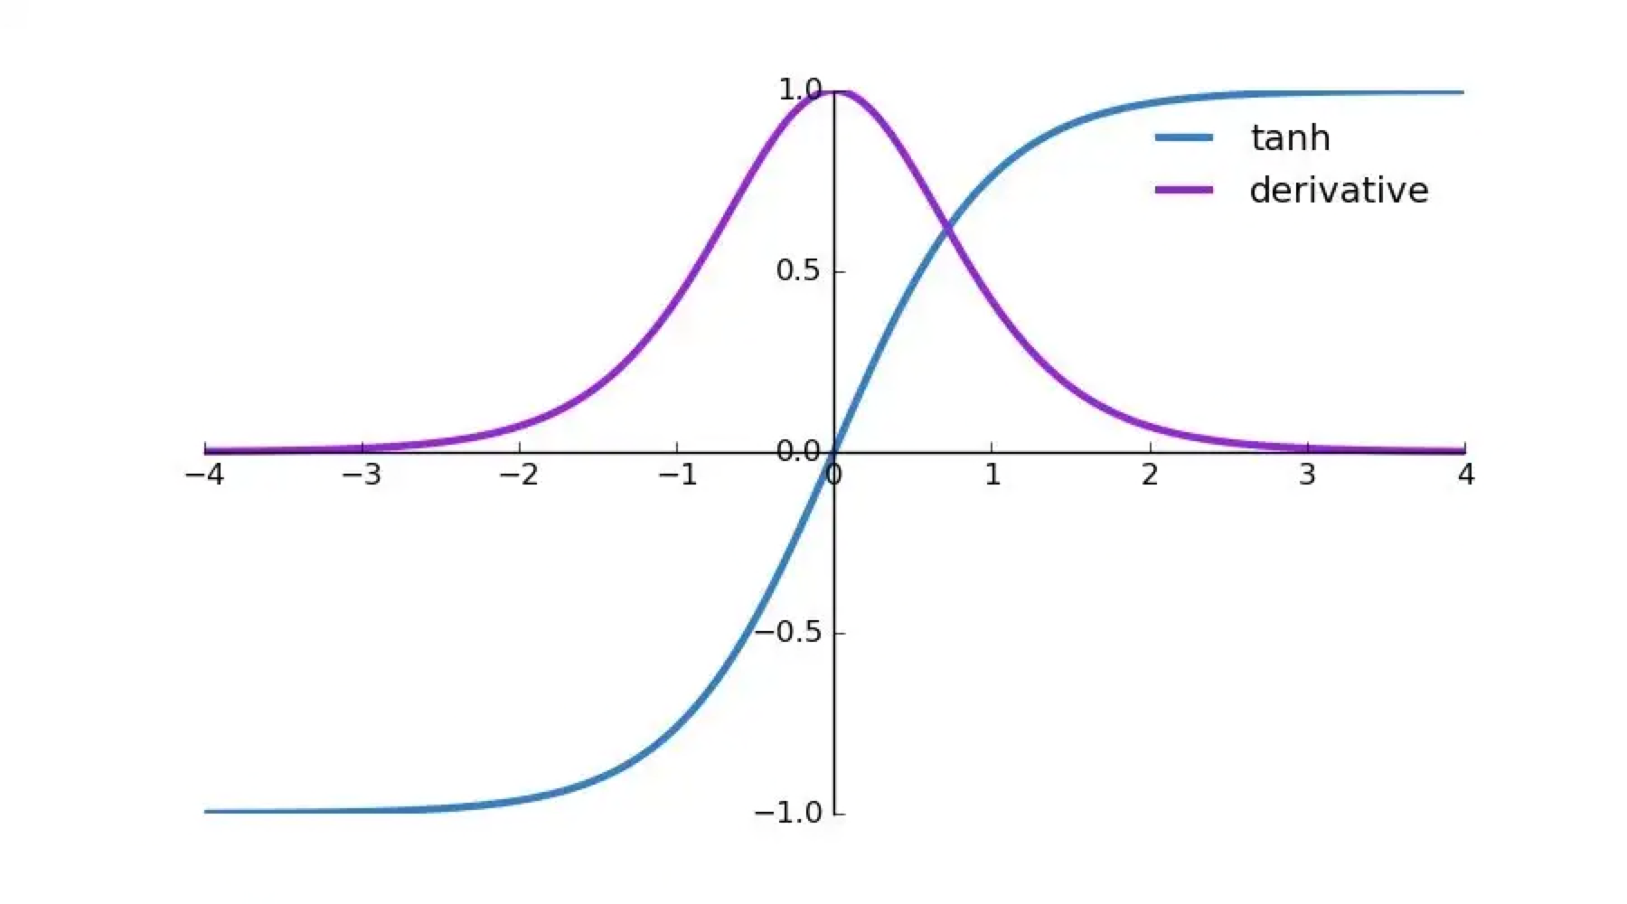

As shown above, tanh provides bigger gradient values than sigmoid.

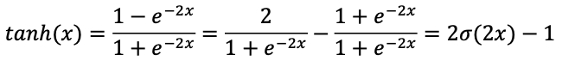4)

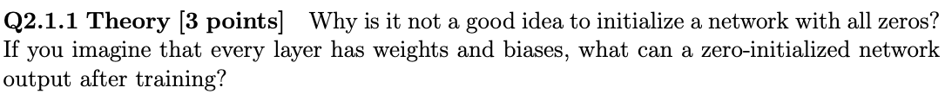

If we set all zero for weight initialization, gradient will be all the same for each layer leading to the same update during training.

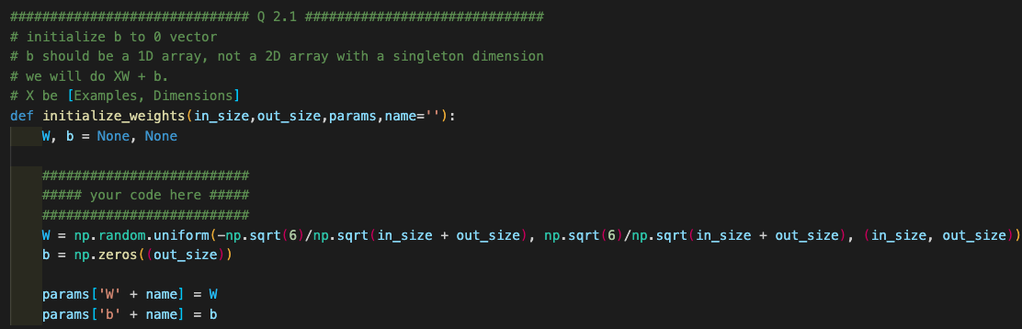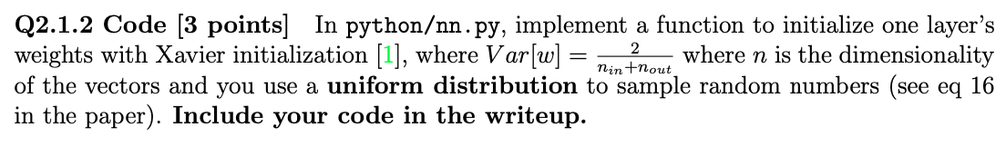



Random initialization: to break symmetry of weights updates

Scaling: to preserve variance of activation at each layer and backpropagated gradients

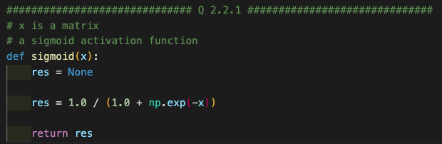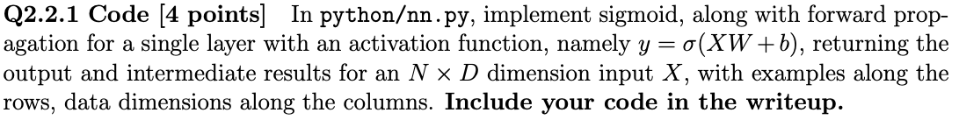

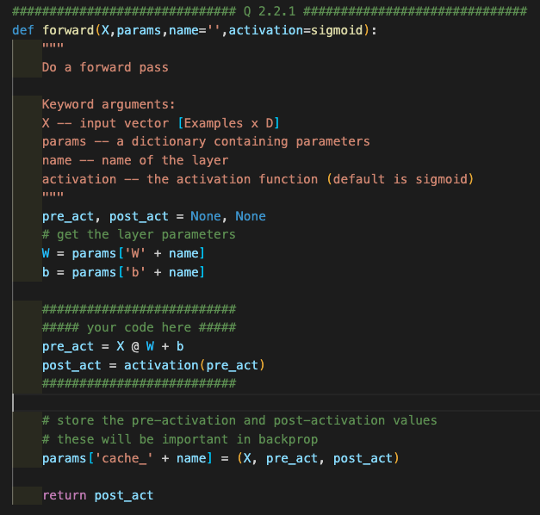

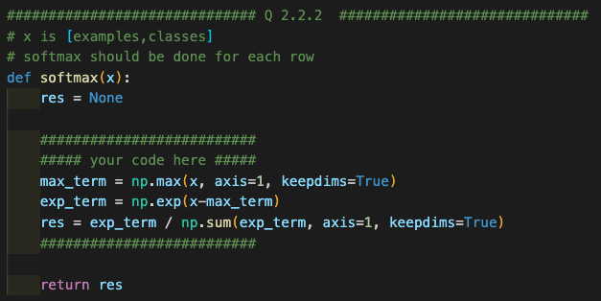

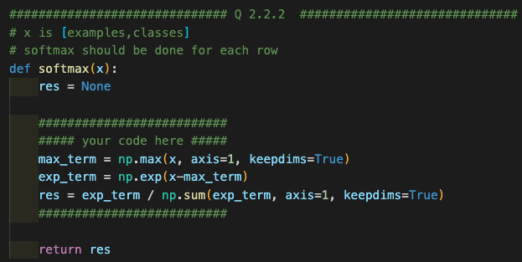

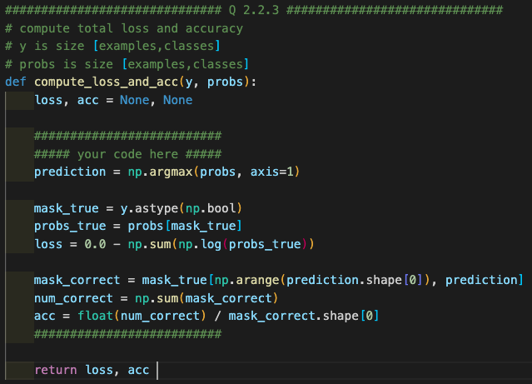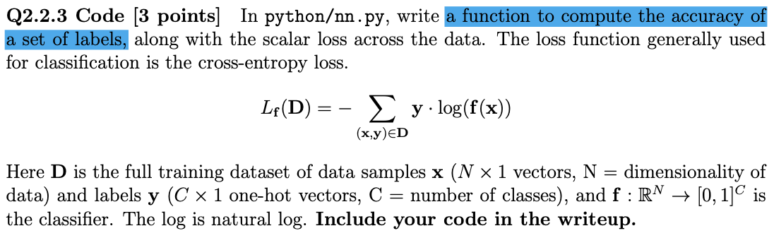

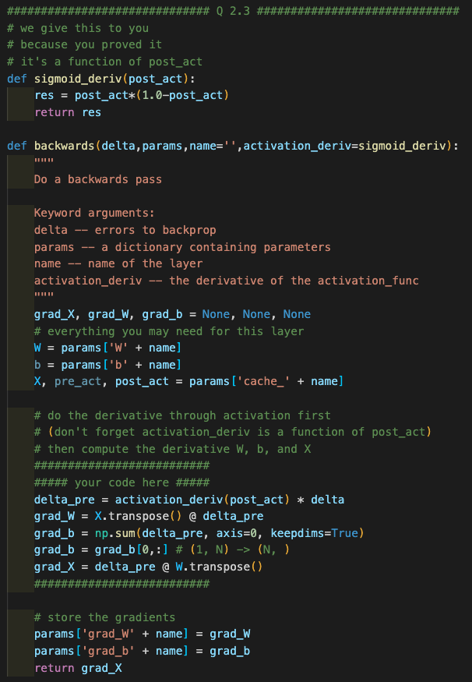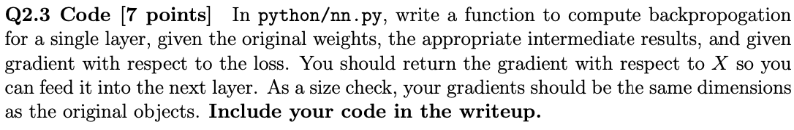

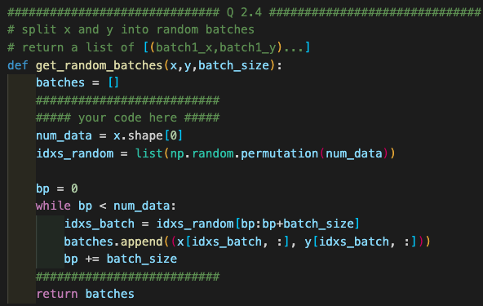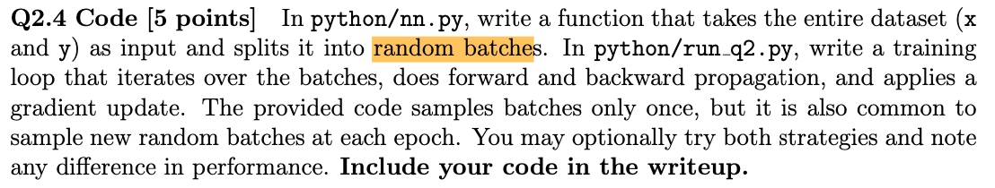

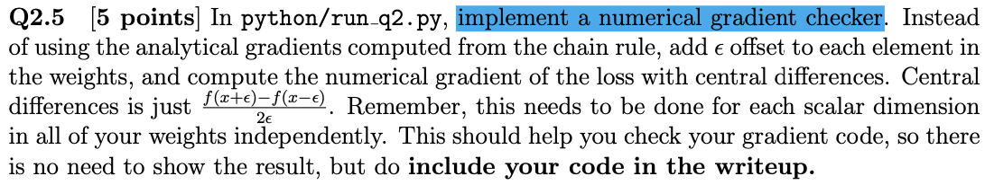

# Q 2.5 should be implemented in this file

# you can do this before or after training the network.

# compute gradients using forward and backward

h1 = forward(x,params,'layer1')

probs = forward(h1,params,'output',softmax)

loss, acc = compute_loss_and_acc(y, probs)

delta1 = probs - y

delta2 = backwards(delta1,params,'output',linear_deriv)

backwards(delta2,params,'layer1',sigmoid_deriv)

# save the old params

import copy

params_orig = copy.deepcopy(params)

# compute gradients using finite difference

eps = 1e-6

for k,v in params.items():

if '_' in k:

continue

# we have a real parameter!

# for each value inside the parameter

# add epsilon

# run the network

# get the loss

# subtract 2*epsilon

# run the network

# get the loss

# restore the original parameter value

# compute derivative with central diffs

##########################

##### your code here #####

if v.ndim == 1:

# print('v.shape is ',v.shape)

# continue

grad_tensor = params['grad_' + k]

for i in range(len(v)):

vij_orig = v[i]

v[i] = vij_orig + eps

h1 = forward(x, params, 'layer1')

probs = forward(h1, params, 'output', softmax)

loss_plus, acc = compute_loss_and_acc(y, probs)

v[i] = vij_orig - eps

h1 = forward(x, params, 'layer1')

probs = forward(h1, params, 'output', softmax)

loss_minus, acc = compute_loss_and_acc(y, probs)

v[i] = vij_orig

diff_grad = (loss_plus - loss_minus) / (2*eps)

grad_tensor[i] = diff_grad

else:

rows, cols = v.shape[0:2]

# print('v.shape is ',v.shape)

# continue

grad_tensor = params['grad_' + k]

for i in range(rows):

for j in range(cols):

vij_orig = v[i, j]

v[i, j] = vij_orig - eps

h1 = forward(x, params, 'layer1')

probs = forward(h1, params, 'output', softmax)

loss_minus, acc = compute_loss_and_acc(y, probs)

v[i, j] = vij_orig + eps

h1 = forward(x, params, 'layer1')

probs = forward(h1, params, 'output', softmax)

loss_plus, acc = compute_loss_and_acc(y, probs)

v[i, j] = vij_orig

diff_grad = (loss_plus - loss_minus) / (2*eps)

grad_tensor[i, j] = diff_grad

##########################

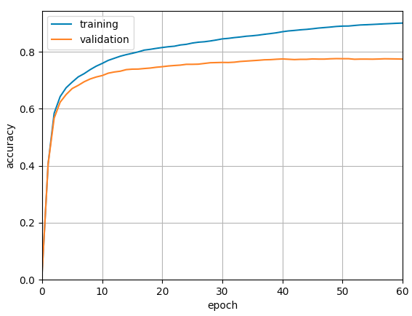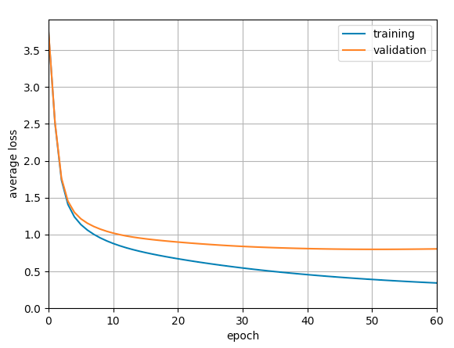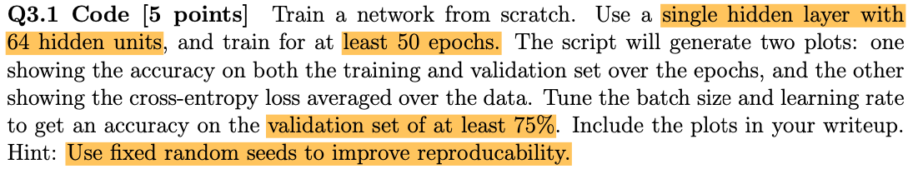

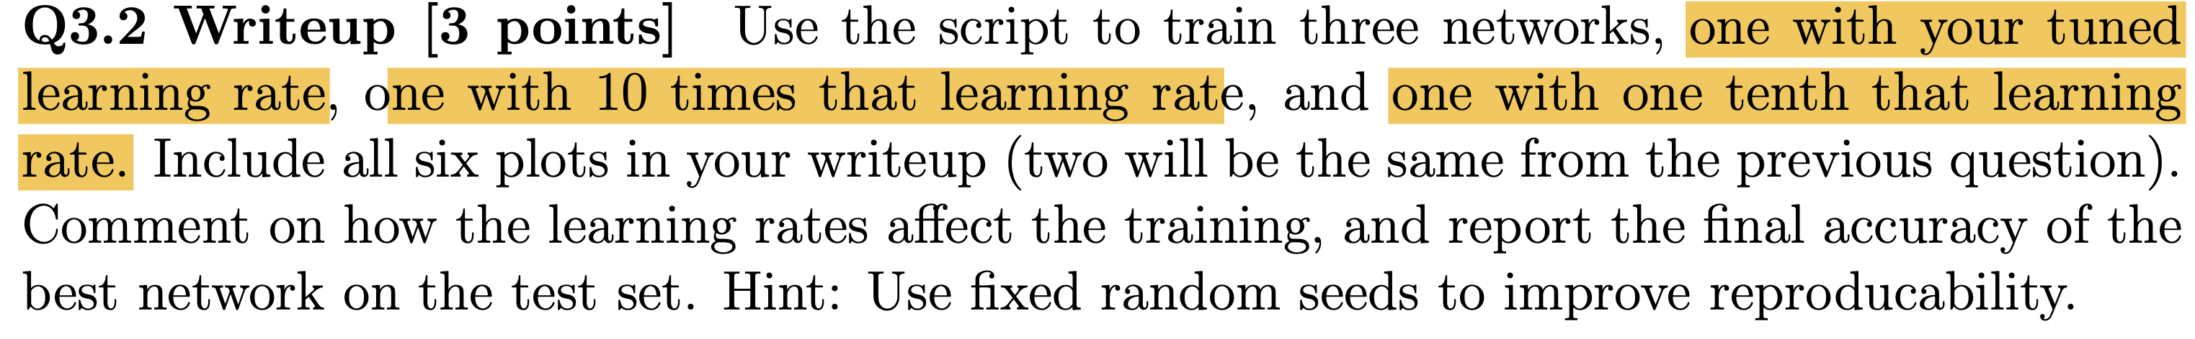

1. 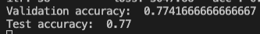Learning rate: 0.005. I achieved the best performance with this learning rate.
2. Learning rate: 0.0005

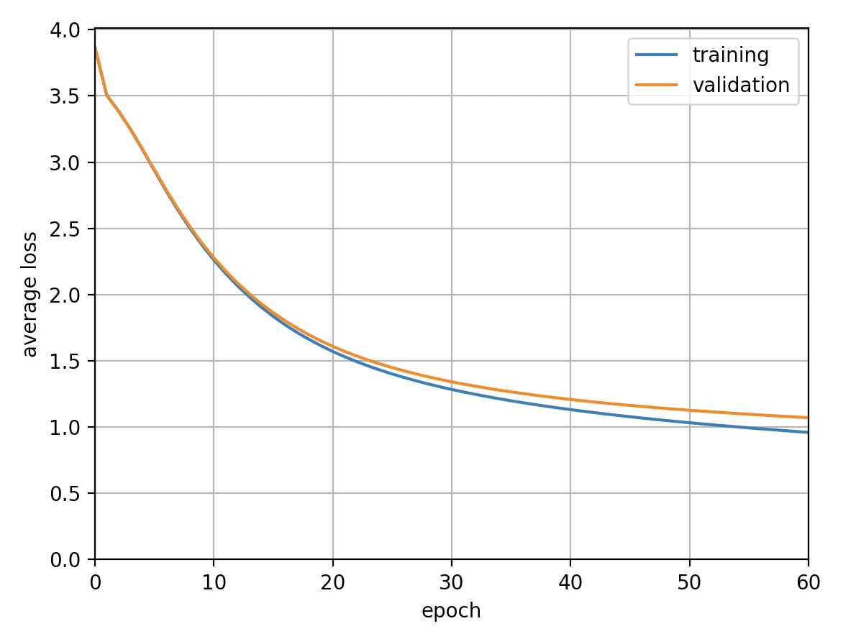

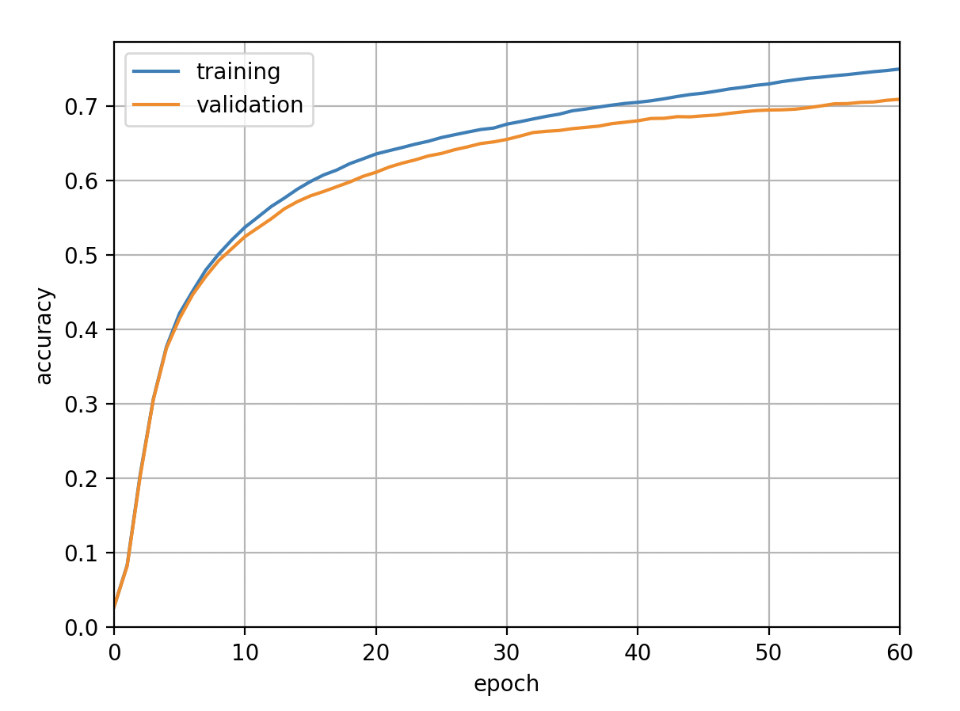

1. Learning rate: 0.05

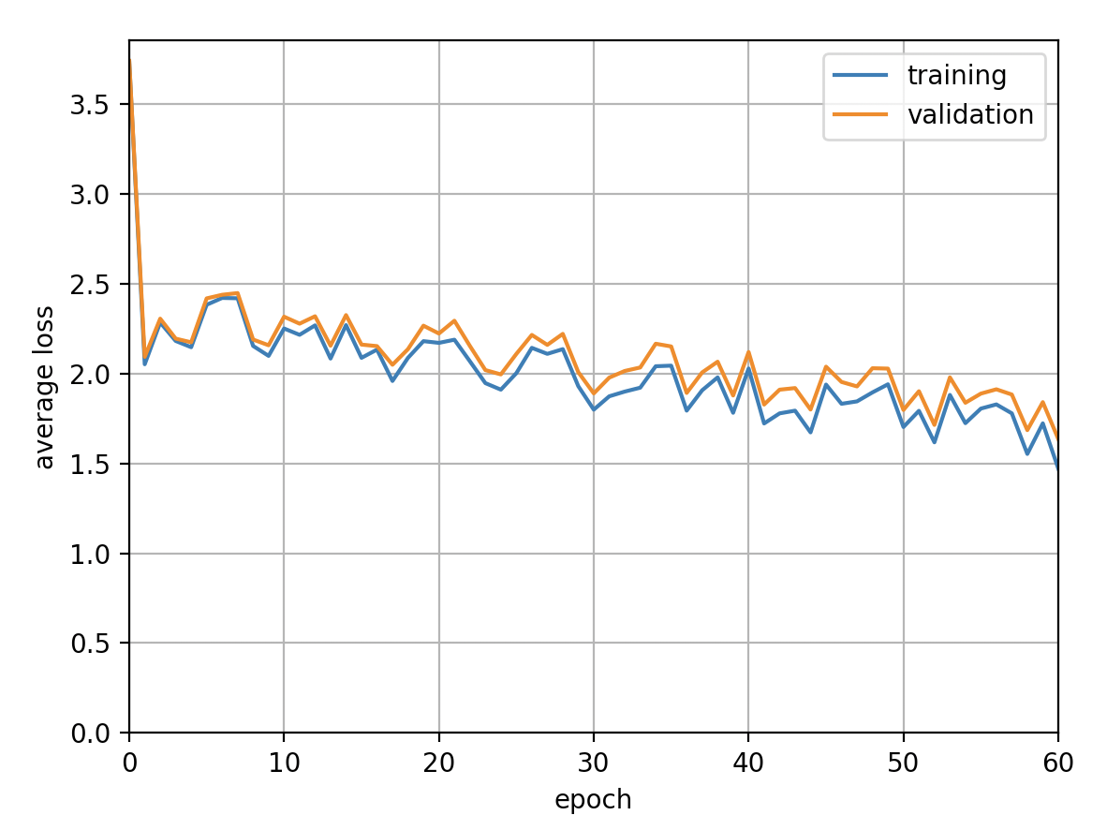

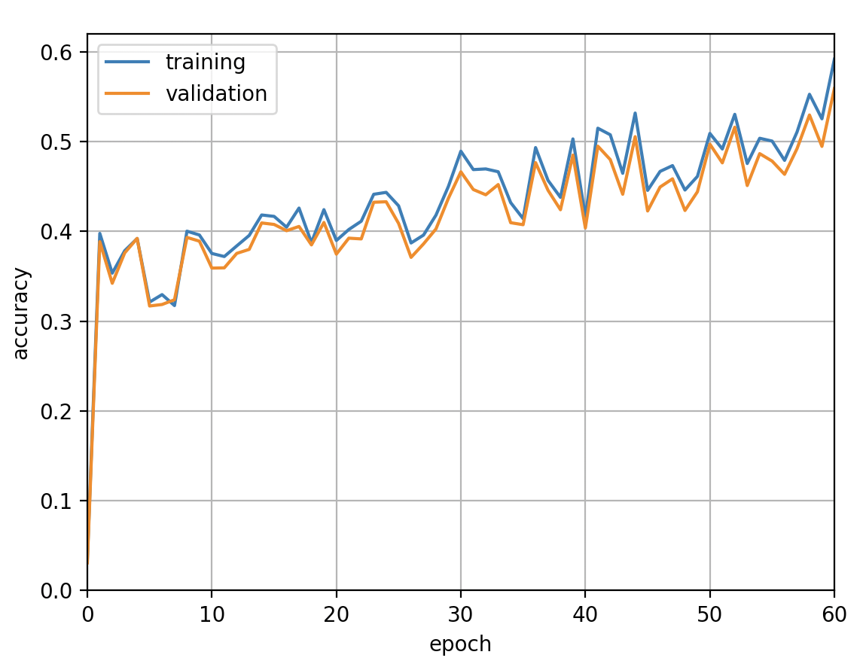

By decreasing learning rate, training got slower and performances between on training set and validation set were almost the same. When learning rate was increased, training was unstable, performance couldn’t be achieved as much high as before.

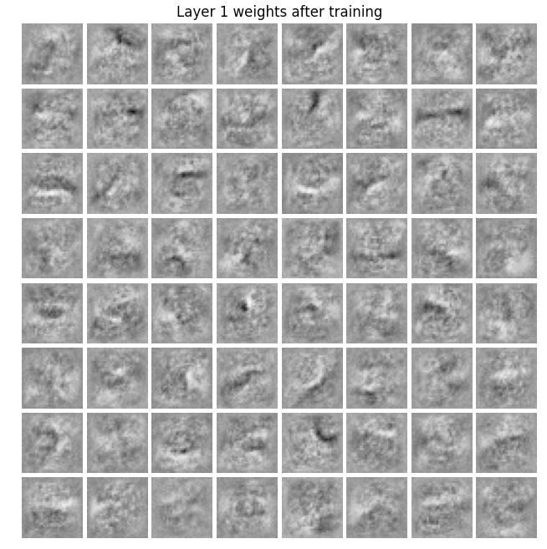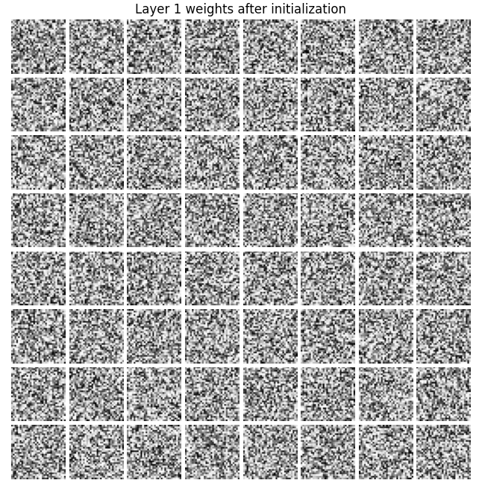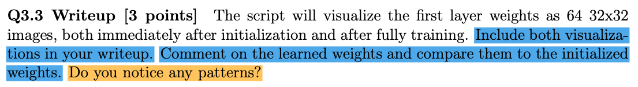D

After training, the weights became blurring and edge capturing filters. Some of them clearly looks some a piece of a letter.



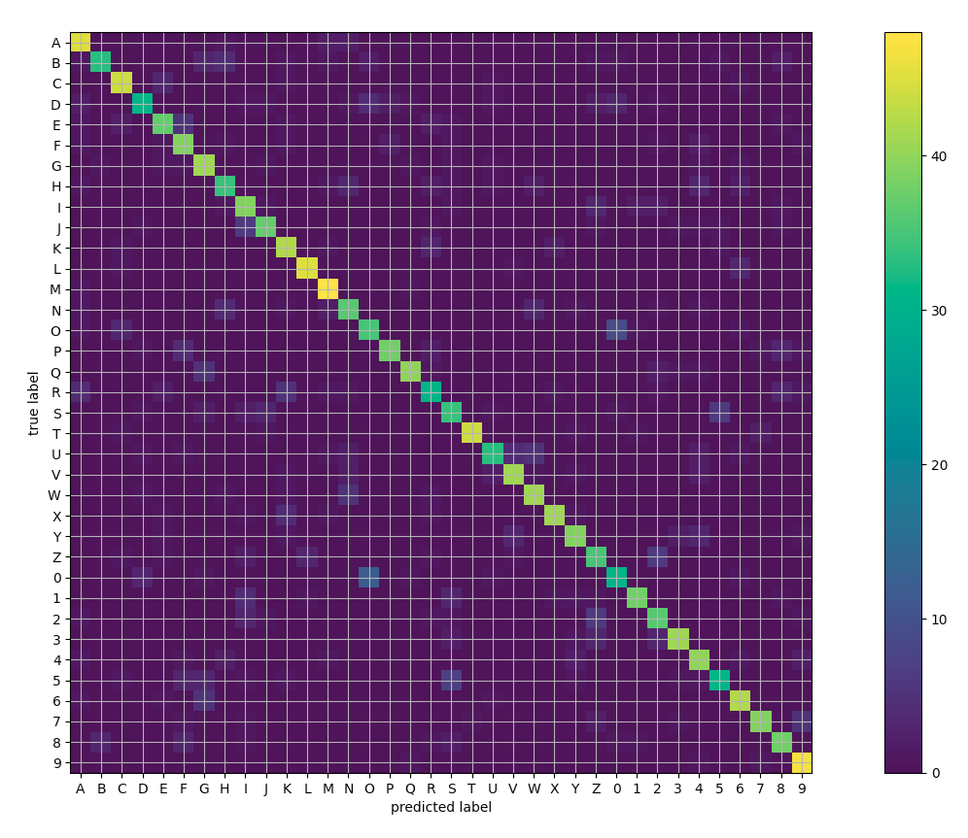

From the result, we can find few pairs of classes that the network confused

1st: 0 and O

2nd: S and 5

3rd: z and 2

All of them are similar letters and the result is understandable.

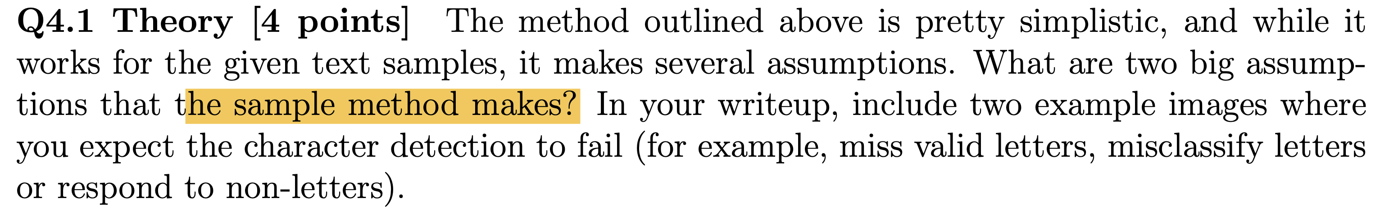

Assumption:

1. Letters are placed separately. Shouldn’t be connected.
2. The size of letters is consistent. Small bounding boxes will be skipped.

Examples:

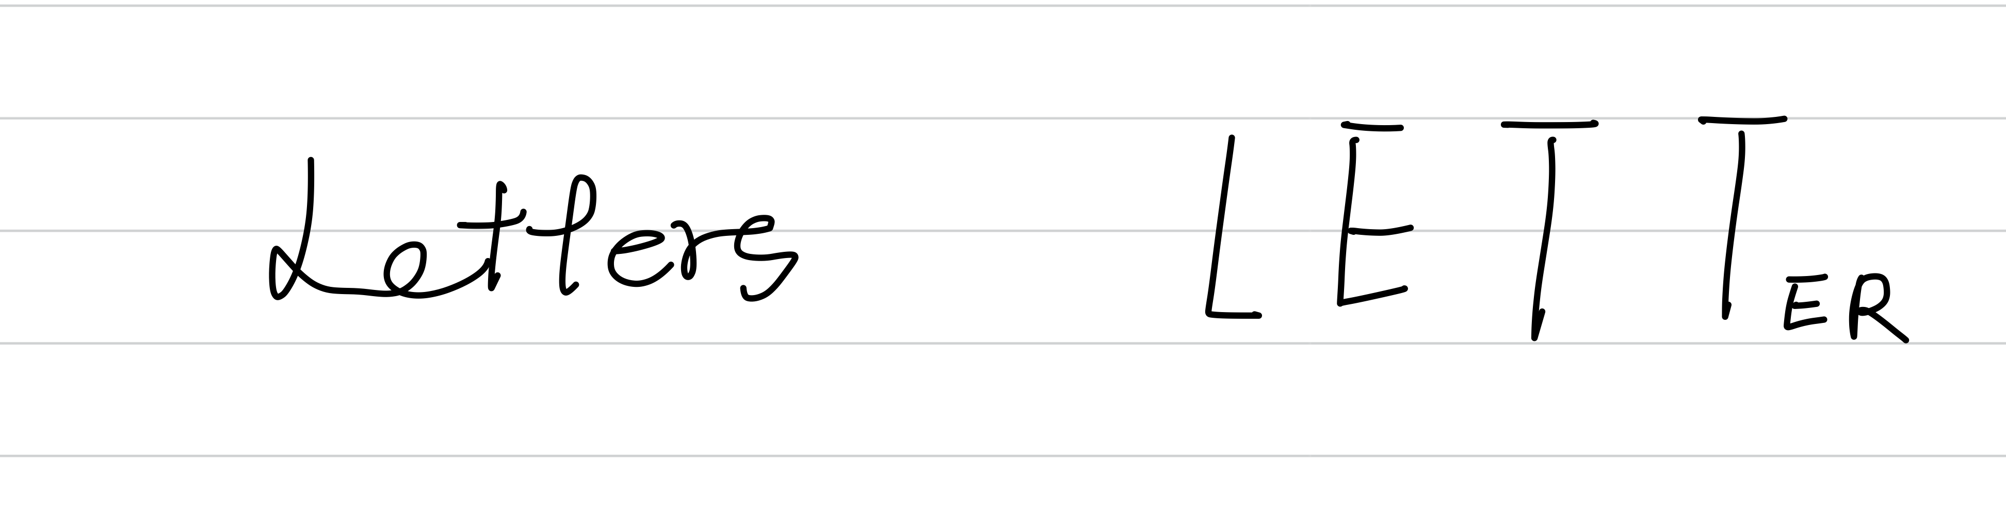

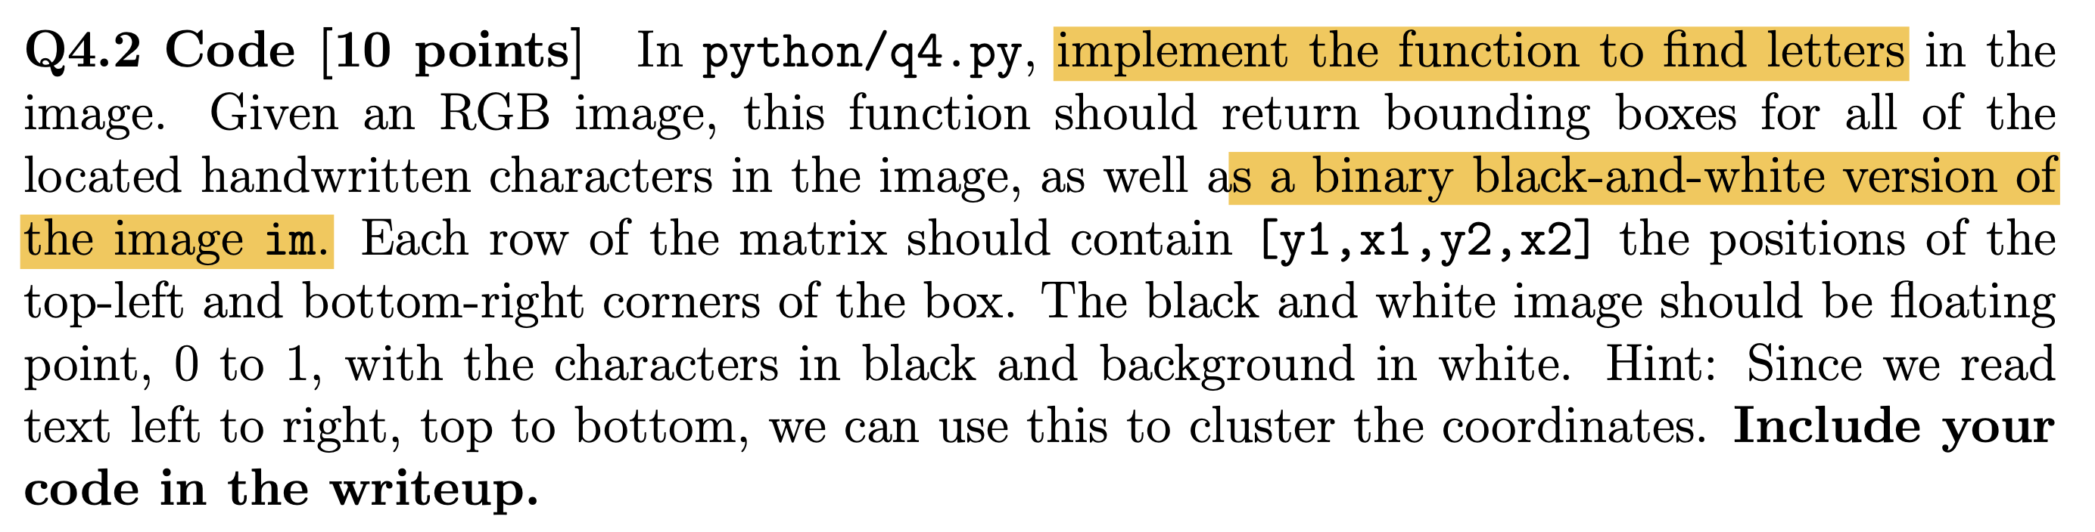

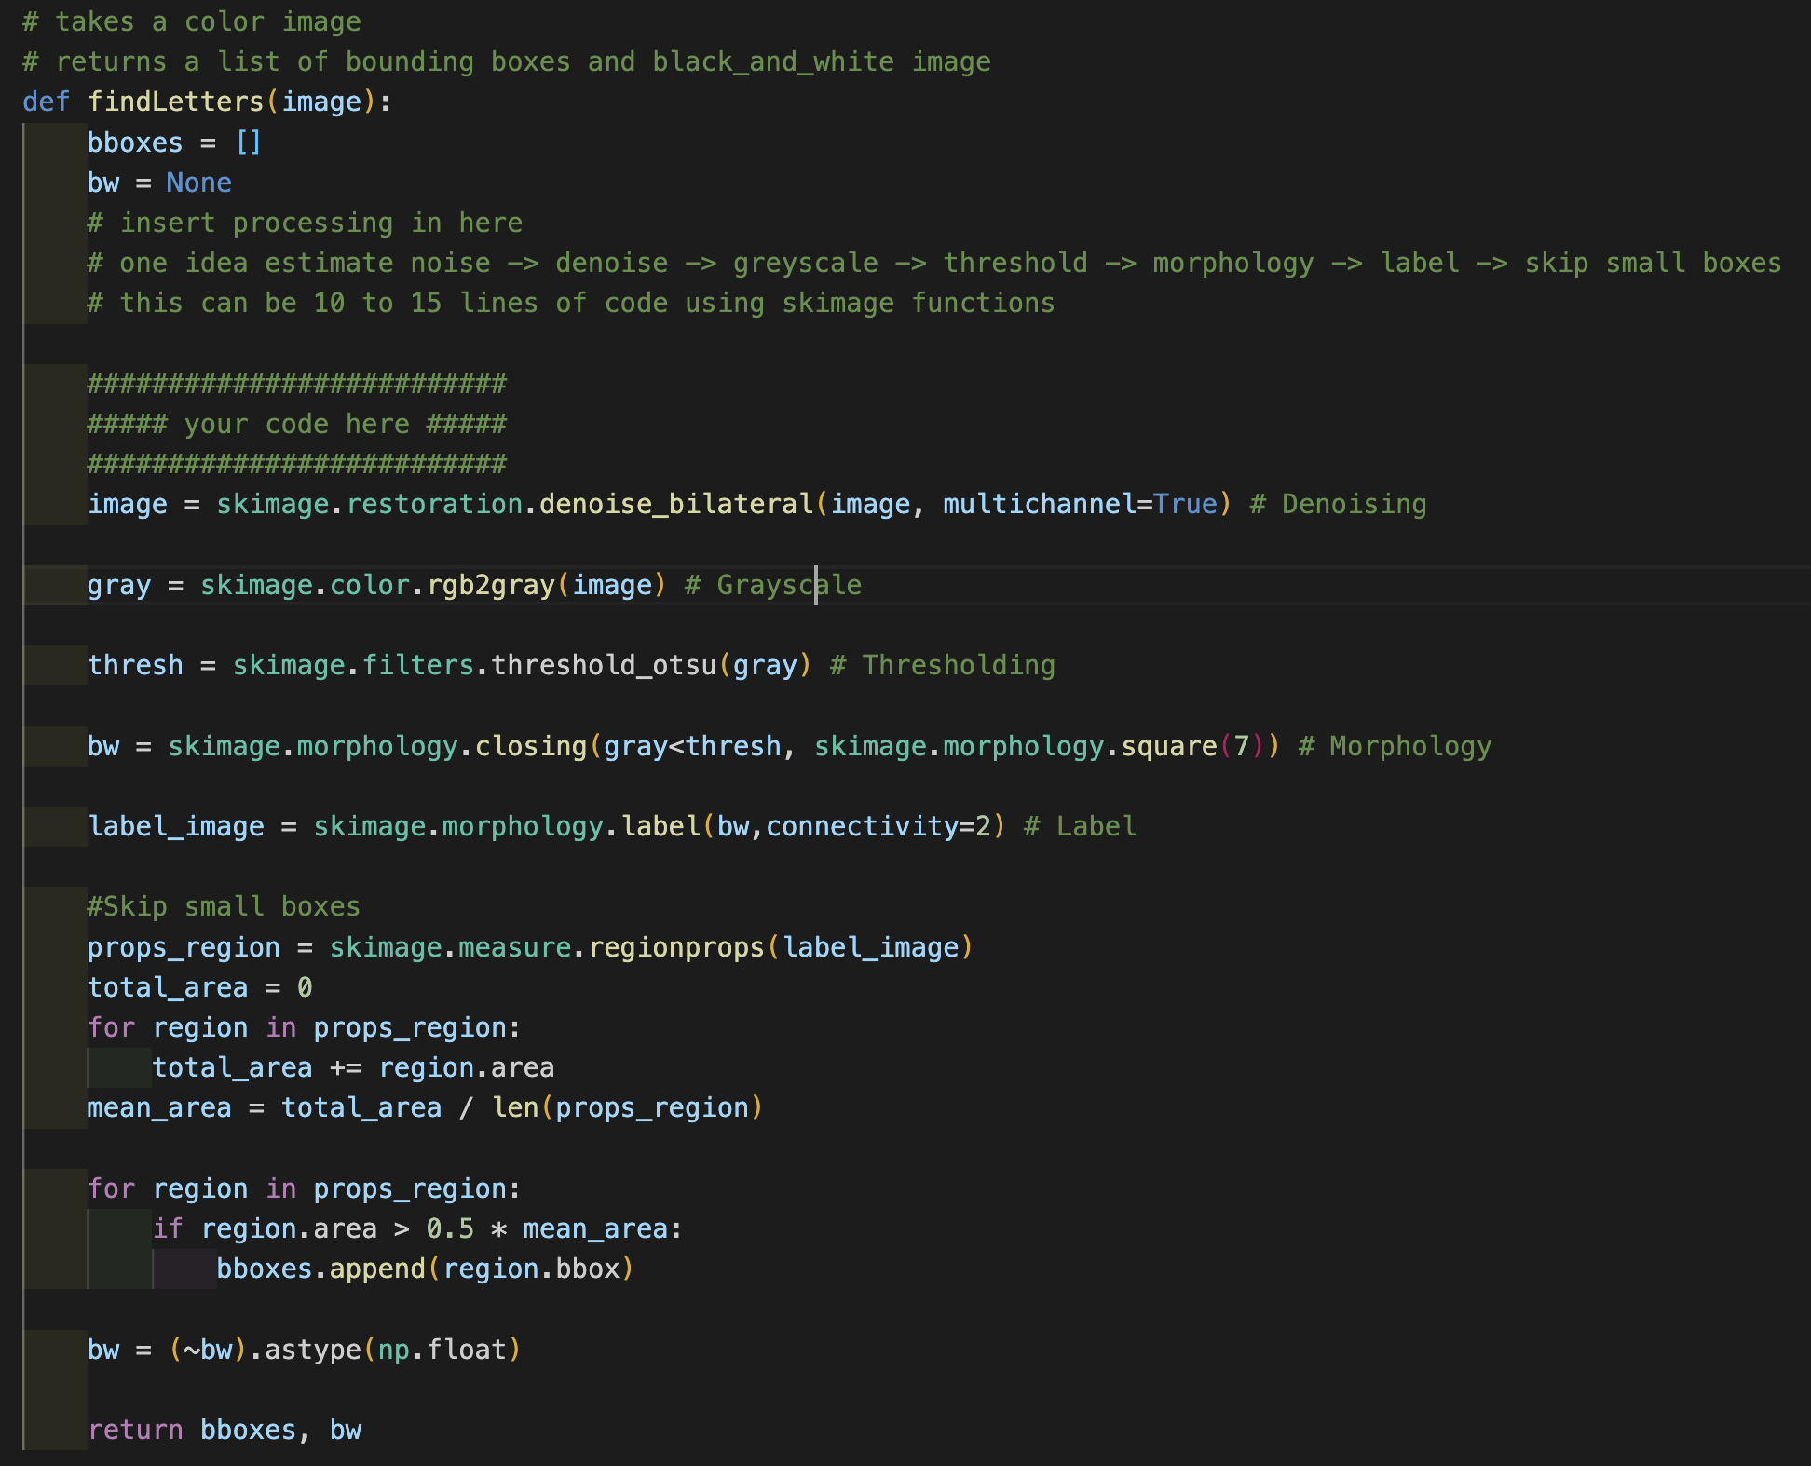

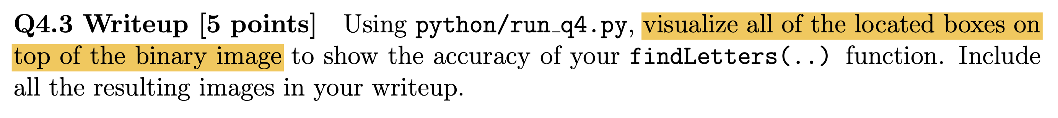

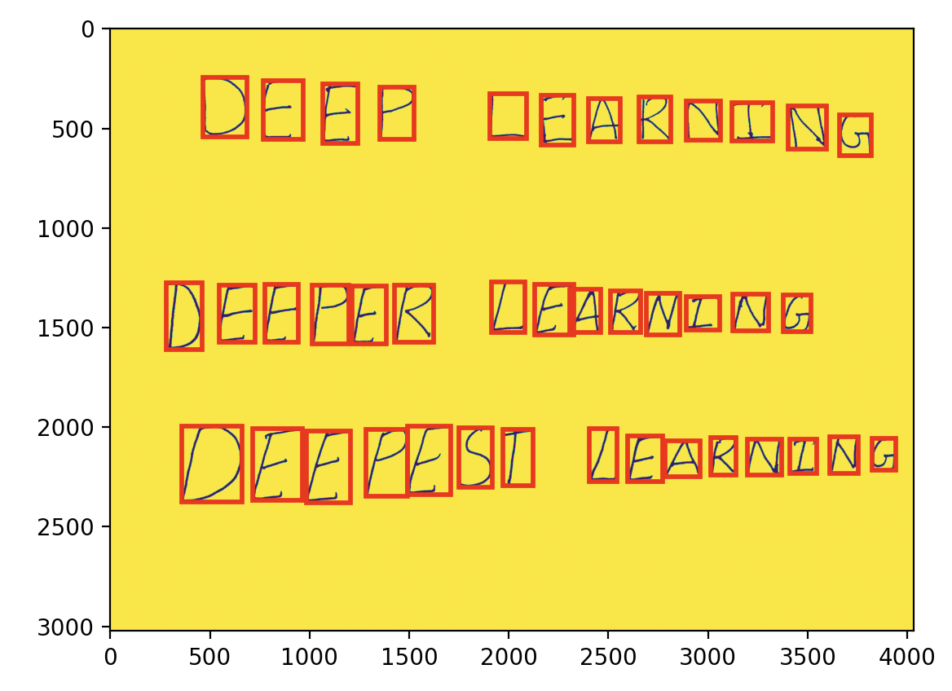

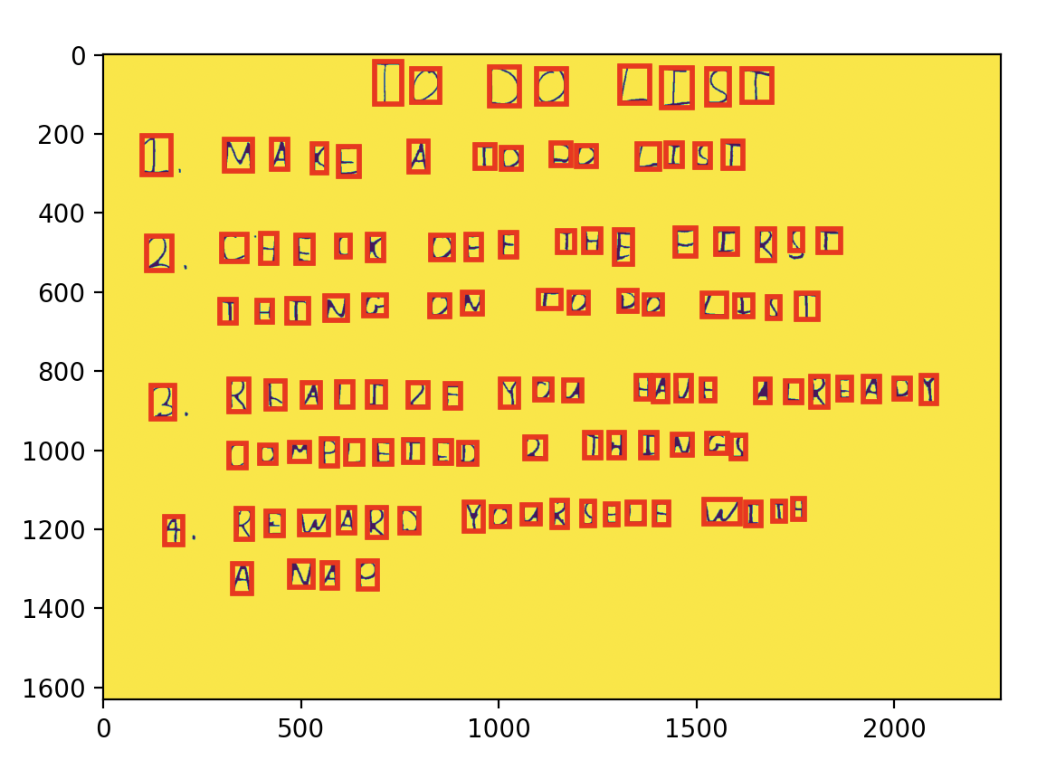

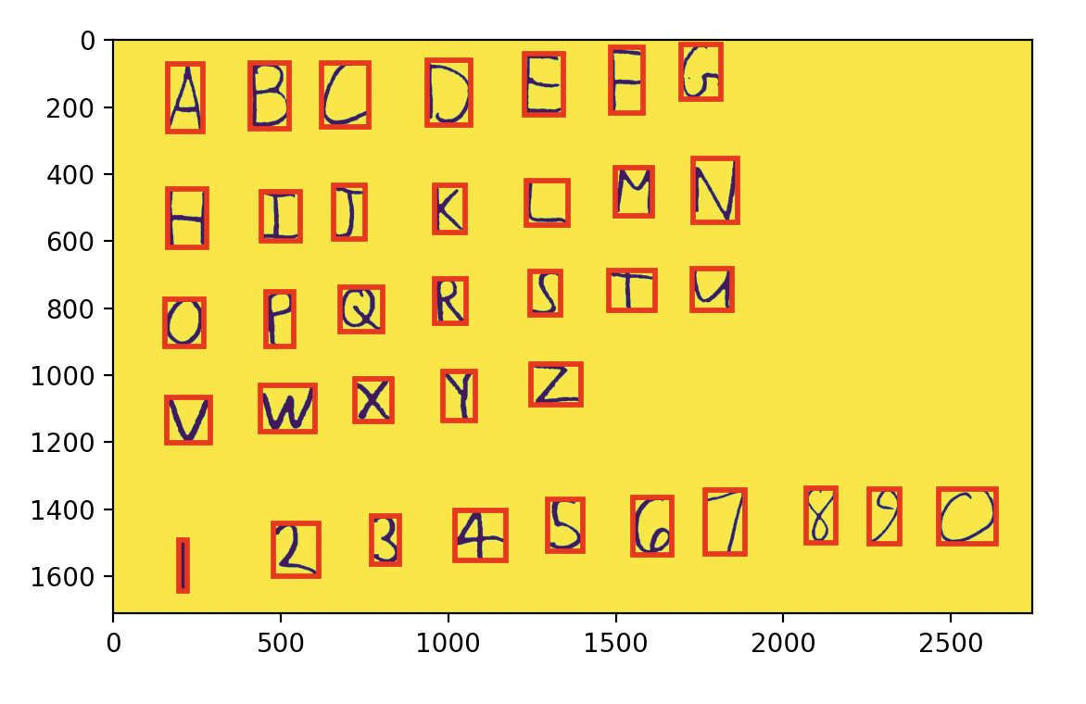

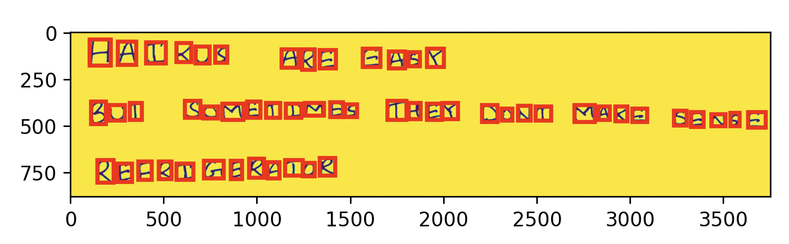

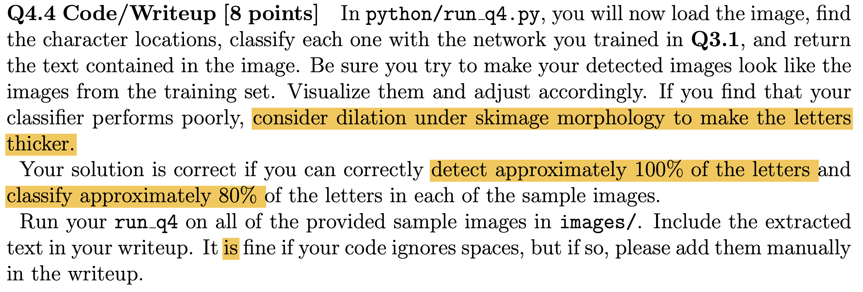

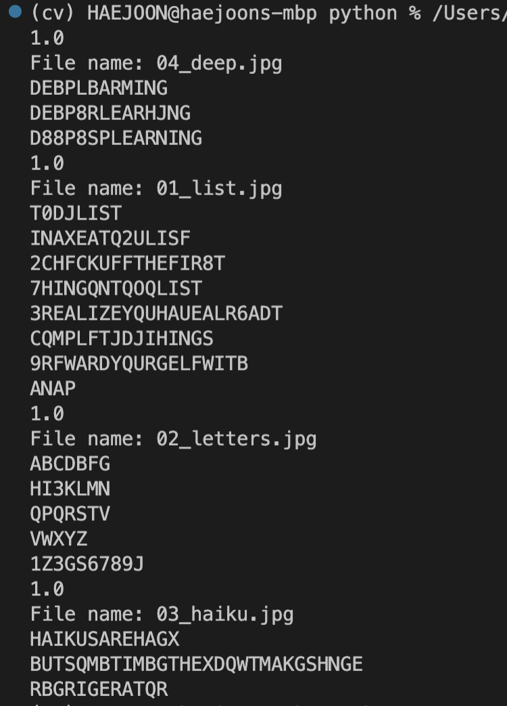

File name: 04_deep.jpg

DEBP LBARMING

DEBP8R LEARHJNG

D88P8SP LEARNING



File name: 01_list.jpg

T0 DJ LIST

I NAXE A TQ2U LISF

2 CHFCK UFF THE FIR8T

7HING QN TQ OQ LIST

3 REALIZE YQU HAUE ALR6ADT

CQMPLFTJD J IHINGS

9 RFWARD YQURGELF WITB

A NAP



File name: 02_letters.jpg

ABCDBFG

HI3KLMN

QPQRSTV

VWXYZ

1Z3GS6789J



File name: 03_haiku.jpg

HAIKUS ARE HAGX

BUT SQMBTIMBG THEX DQWT MAKG SHNGE

RBGRIGERATQR



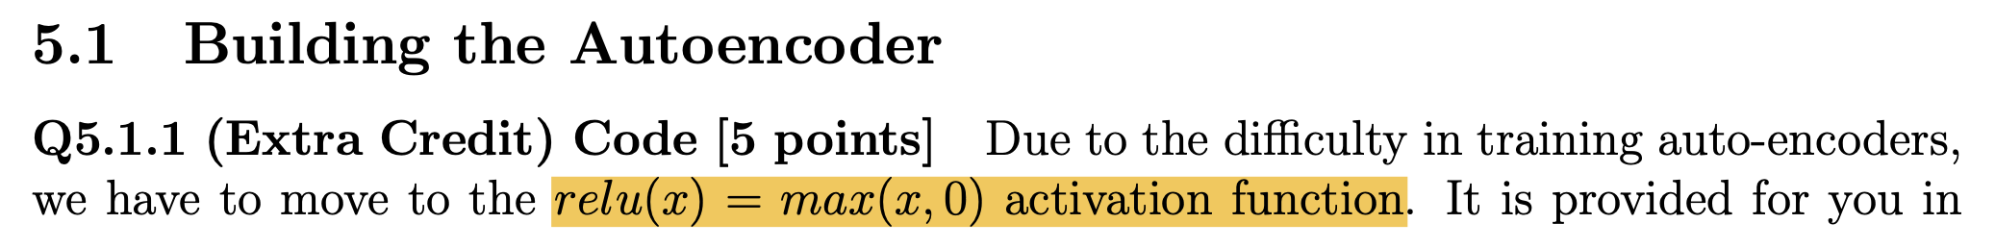

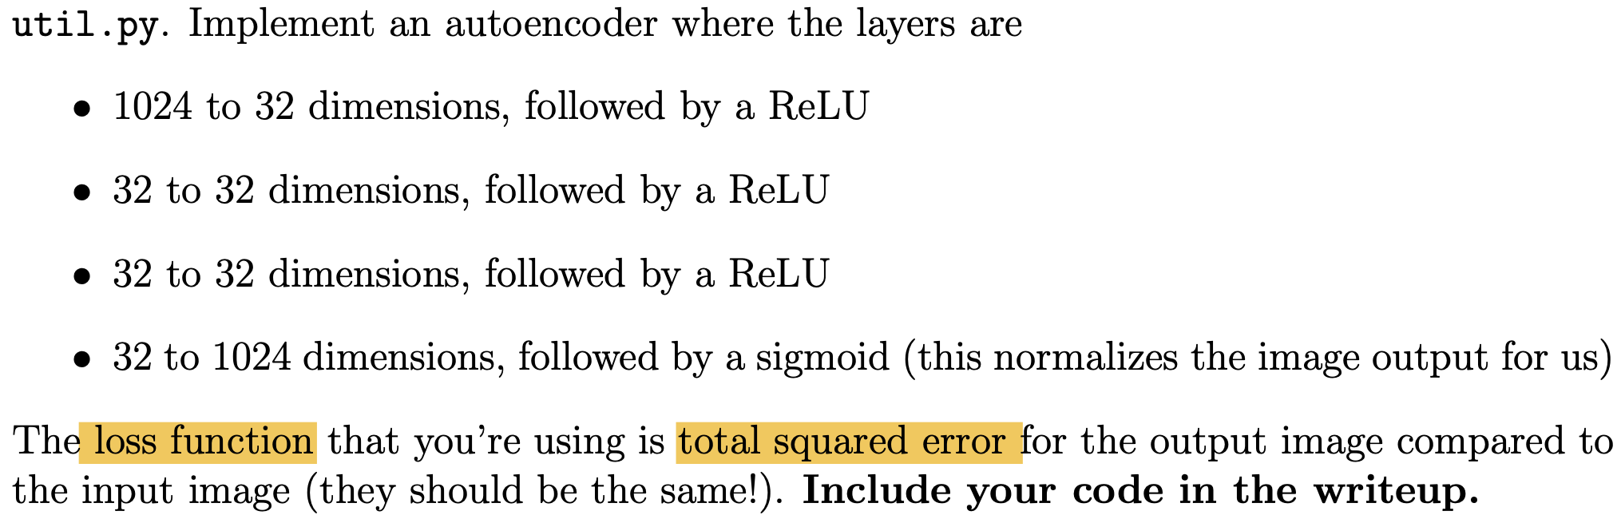

# Q5.1 & Q5.2

# initialize layers here

##########################

##### your code here #####

##########################

in_size = train_x.shape[1] # 1024

initialize_weights(in_size, hidden_size, params, 'layer1')

initialize_weights(hidden_size, hidden_size,params, 'hidden1')

initialize_weights(hidden_size, hidden_size,params, 'hidden2')

initialize_weights(hidden_size, in_size,params, 'output')

# Make new params (m_Wlayer1, ...) for momentum

keys = [k for k in params.keys()]

for k in keys:

params['m_' + k] = np.zeros(params[k].shape)

# should look like your previous training loops

losses = []

for itr in range(max_iters):

total_loss = 0

for xb,_ in batches:

# training loop can be exactly the same as q2!

# your loss is now squared error

# delta is the d/dx of (x-y)^2

# to implement momentum

# just use 'm_'+name variables

# to keep a saved value over timestamps

# params is a Counter(), which returns a 0 if an element is missing

# so you should be able to write your loop without any special conditions

##########################

##### your code here #####

##########################

pass

h1 = forward(X=xb, params=params, name='layer1', activation=relu)

h2 = forward(X=h1, params=params, name='hidden1', activation=relu)

h3 = forward(X=h2, params=params, name='hidden2', activation=relu)

x_recon = forward(X=h3, params=params, name='output', activation=sigmoid)

loss = np.sum((x_recon-xb)**2)

total_loss += loss

delta1 = 2*(x_recon-xb)

delta2 = backwards(delta=delta1, params=params, name='output', activation_deriv=sigmoid_deriv)

delta3 = backwards(delta=delta2, params=params, name='hidden2', activation_deriv=relu_deriv)

delta4 = backwards(delta=delta3, params=params, name='hidden1', activation_deriv=relu_deriv)

backwards(delta=delta4, params=params, name='layer1', activation_deriv=relu_deriv)

# Momentum update

for k in params.keys():

if '_' not in k:

params['m_'+k] = 0.9 * params['m_'+k] - learning_rate * params['grad_'+k]

params[k] += params['m_'+k]

losses.append(total_loss/train_x.shape[0])

if itr % 2 == 0:

print("itr: {:02d} \t loss: {:.2f}".format(itr, total_loss))

if itr % lr_rate == lr_rate - 1:

learning_rate *= 0.9

# plot loss curve

plt.plot(range(len(losses)), losses)

plt.xlabel("epoch")

plt.ylabel("average loss")

plt.xlim(0, len(losses)-1)

plt.ylim(0, None)

plt.grid()

plt.show()

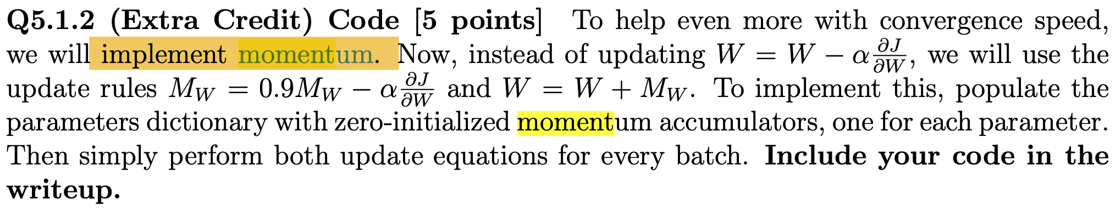

Same code for Q5.1.1

# Q5.1 & Q5.2

# initialize layers here

##########################

##### your code here #####

##########################

in_size = train_x.shape[1] # 1024

initialize_weights(in_size, hidden_size, params, 'layer1')

initialize_weights(hidden_size, hidden_size,params, 'hidden1')

initialize_weights(hidden_size, hidden_size,params, 'hidden2')

initialize_weights(hidden_size, in_size,params, 'output')

# Make new params (m_Wlayer1, ...) for momentum

keys = [k for k in params.keys()]

for k in keys:

params['m_' + k] = np.zeros(params[k].shape)

# should look like your previous training loops

losses = []

for itr in range(max_iters):

total_loss = 0

for xb,_ in batches:

# training loop can be exactly the same as q2!

# your loss is now squared error

# delta is the d/dx of (x-y)^2

# to implement momentum

# just use 'm_'+name variables

# to keep a saved value over timestamps

# params is a Counter(), which returns a 0 if an element is missing

# so you should be able to write your loop without any special conditions

##########################

##### your code here #####

##########################

pass

h1 = forward(X=xb, params=params, name='layer1', activation=relu)

h2 = forward(X=h1, params=params, name='hidden1', activation=relu)

h3 = forward(X=h2, params=params, name='hidden2', activation=relu)

x_recon = forward(X=h3, params=params, name='output', activation=sigmoid)

loss = np.sum((x_recon-xb)**2)

total_loss += loss

delta1 = 2*(x_recon-xb)

delta2 = backwards(delta=delta1, params=params, name='output', activation_deriv=sigmoid_deriv)

delta3 = backwards(delta=delta2, params=params, name='hidden2', activation_deriv=relu_deriv)

delta4 = backwards(delta=delta3, params=params, name='hidden1', activation_deriv=relu_deriv)

backwards(delta=delta4, params=params, name='layer1', activation_deriv=relu_deriv)

# Momentum update

for k in params.keys():

if '_' not in k:

params['m_'+k] = 0.9 * params['m_'+k] - learning_rate * params['grad_'+k]

params[k] += params['m_'+k]

losses.append(total_loss/train_x.shape[0])

if itr % 2 == 0:

print("itr: {:02d} \t loss: {:.2f}".format(itr, total_loss))

if itr % lr_rate == lr_rate - 1:

learning_rate *= 0.9

# plot loss curve

plt.plot(range(len(losses)), losses)

plt.xlabel("epoch")

plt.ylabel("average loss")

plt.xlim(0, len(losses)-1)

plt.ylim(0, None)

plt.grid()

plt.show()

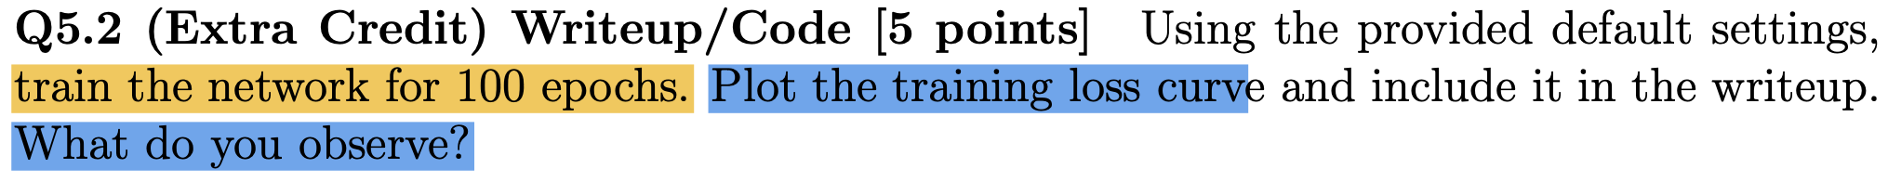

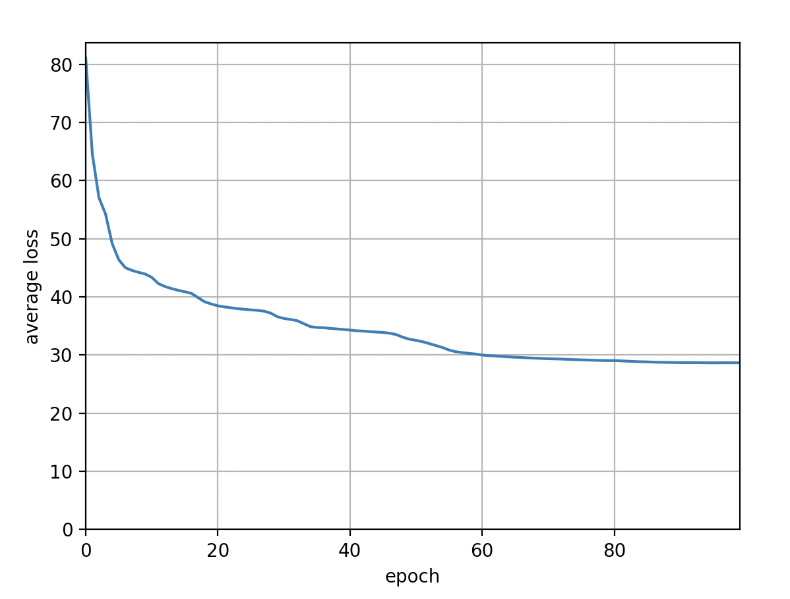

The average loss saturated after 80 epochs even during training.

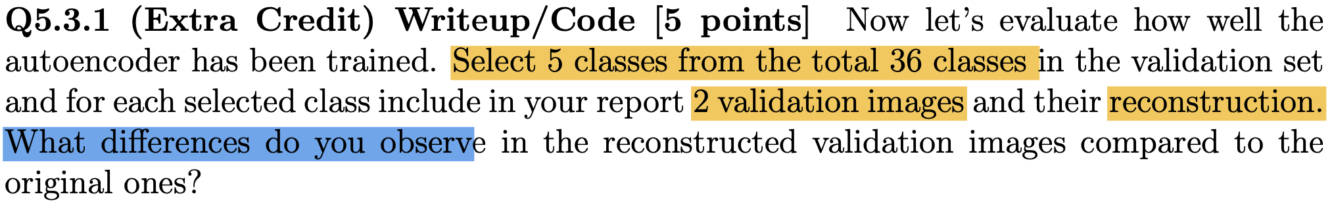

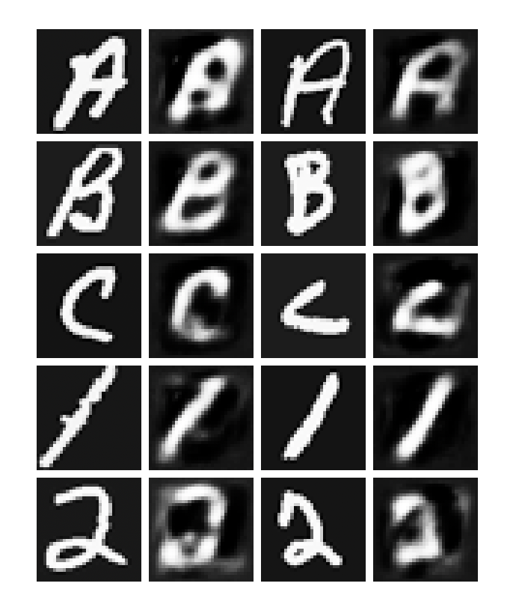

The reconstructed images were at the similar shape with original images but much blurrier.

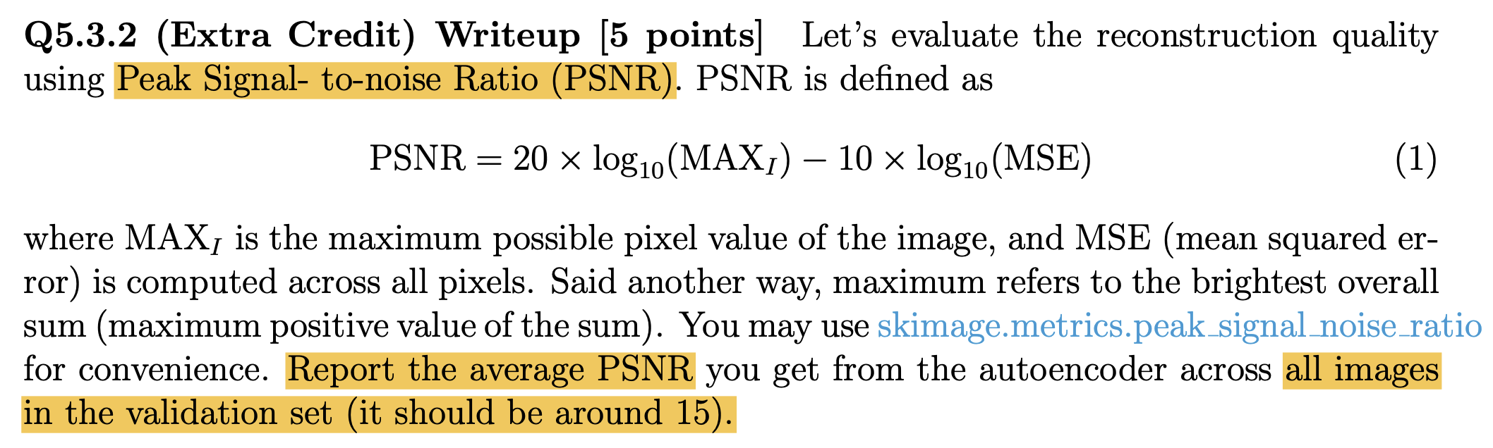

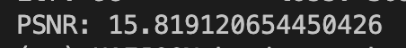



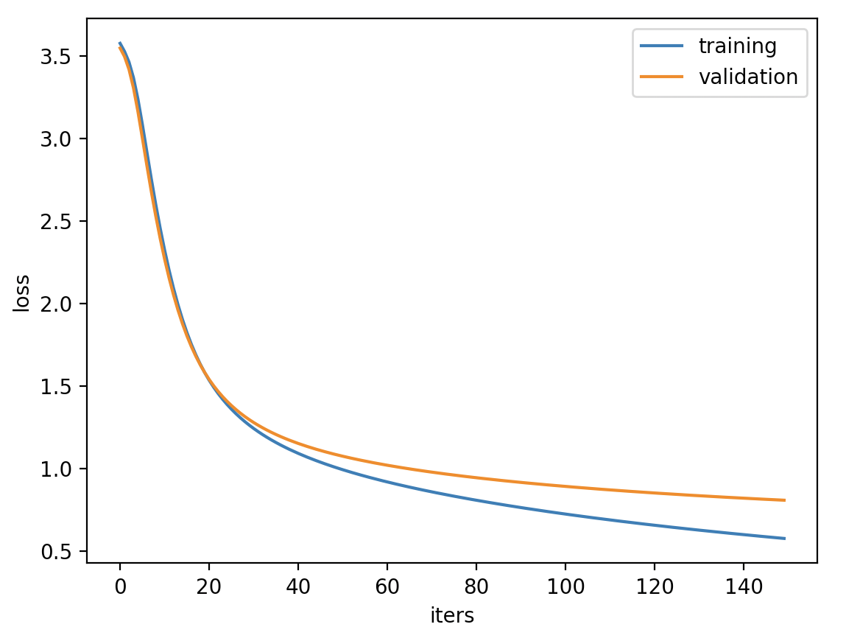

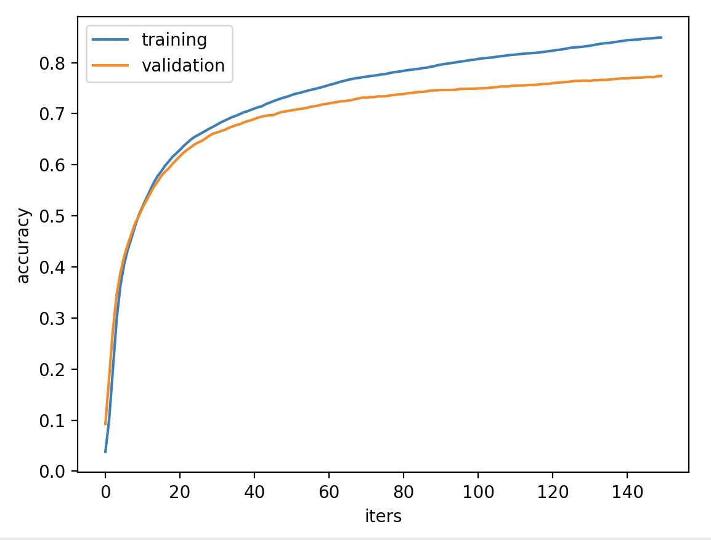



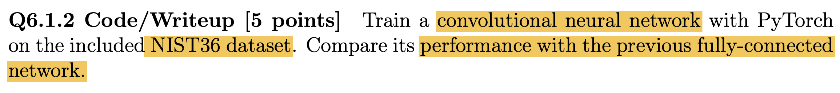

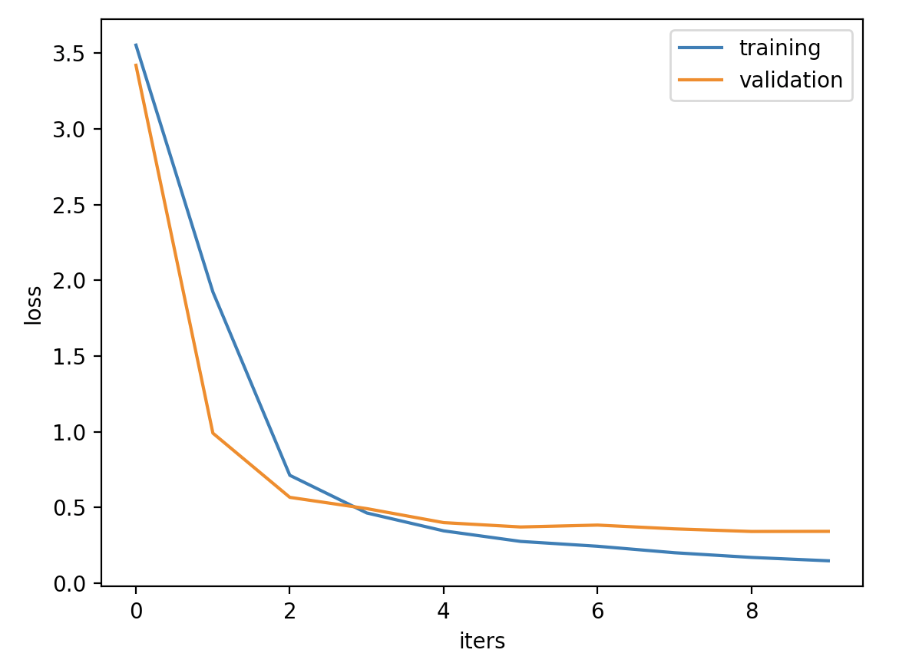

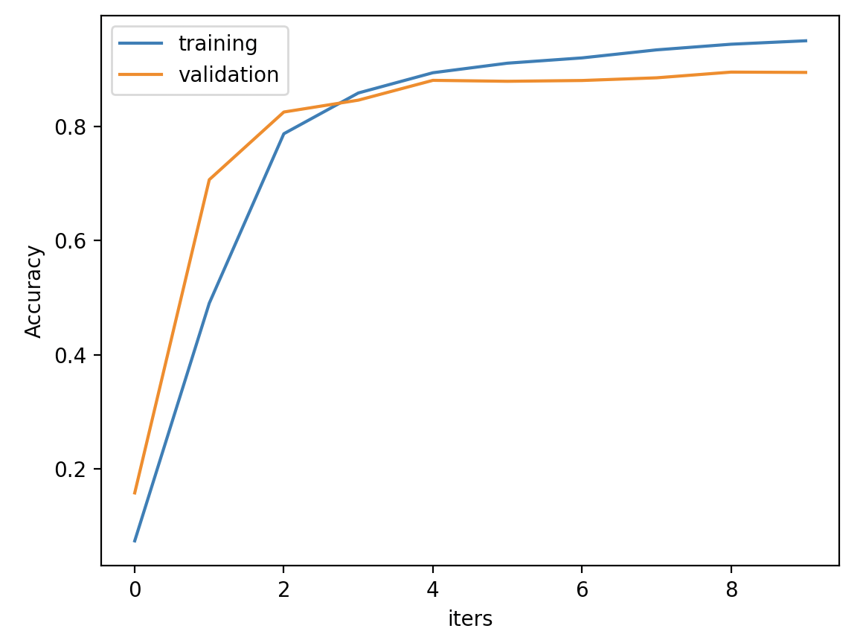

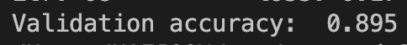

Only with 10 iterations (FC: 100 iterations), CNN could achieve higher performance (Validation accuracy: CNN - 89%, FCN – 77%)



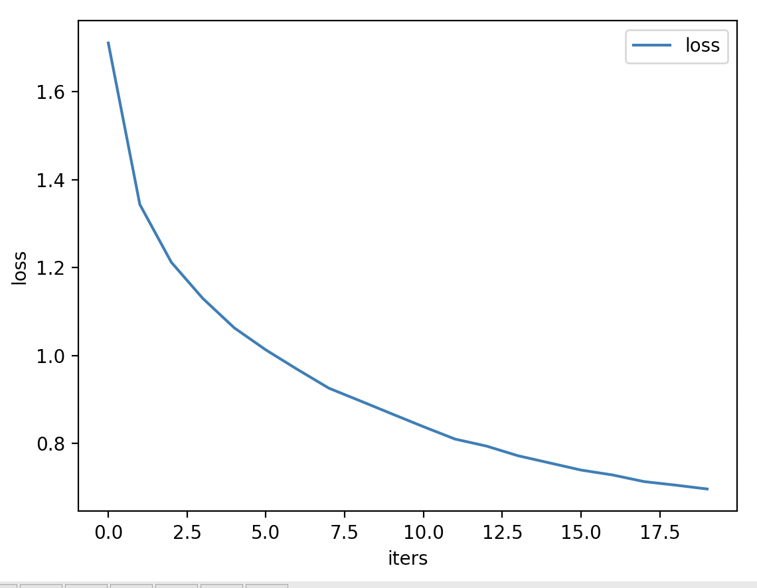

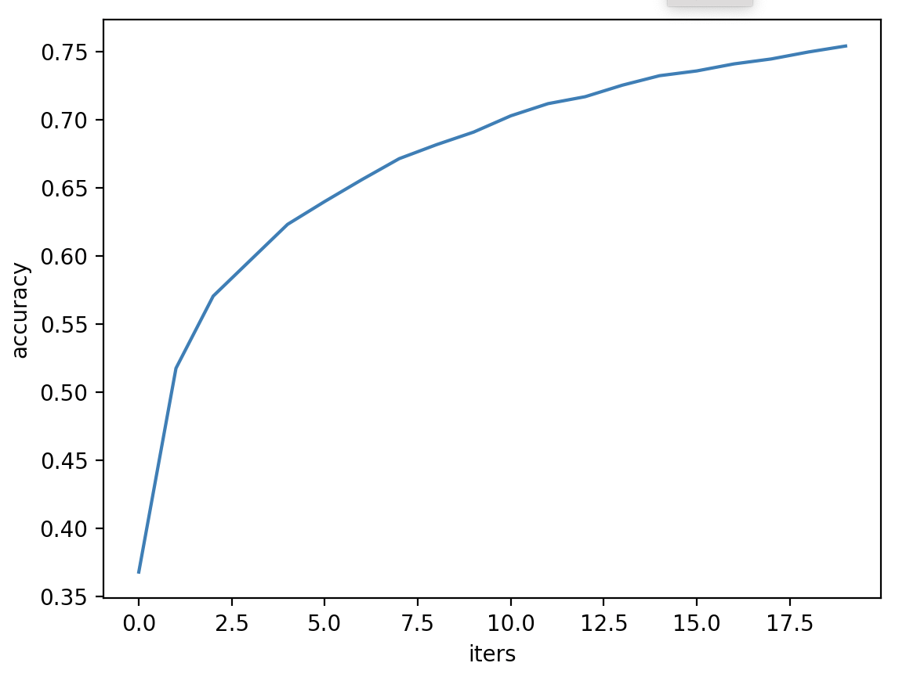

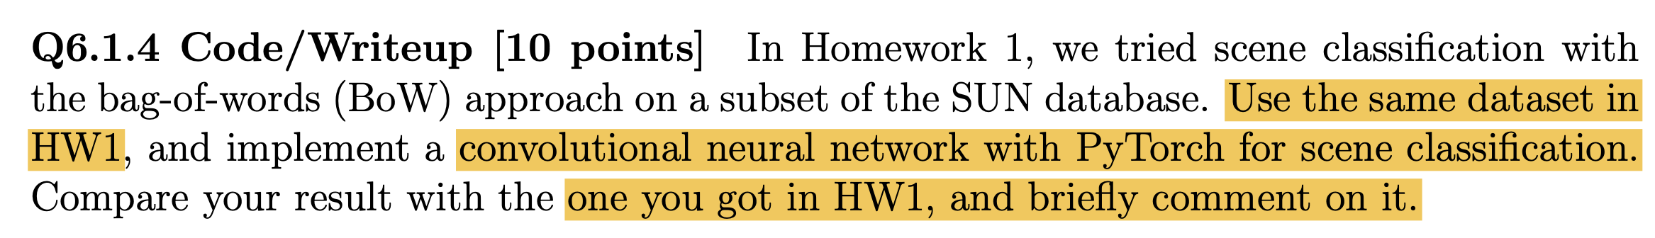

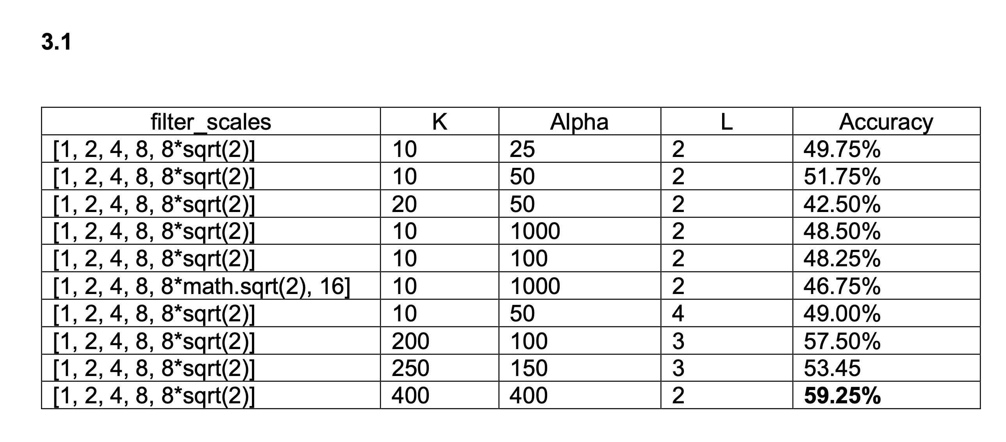

Above result is from HW1. The highest Accuracy was 59.25%. And the simple CNN, SUNet, could provide 74% accuracy on the same testing dataset as shown below. It is expected to due to that CNN could learn much contextual information and has bigger capacity (more learnable parameters).

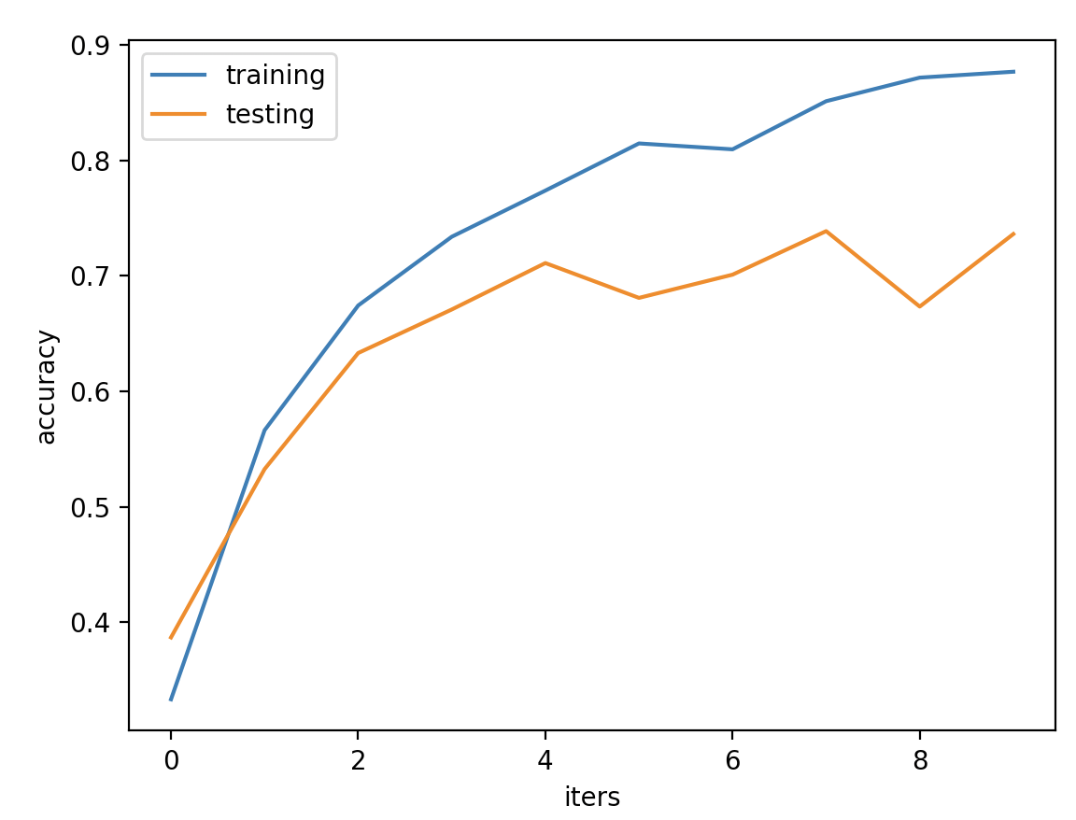

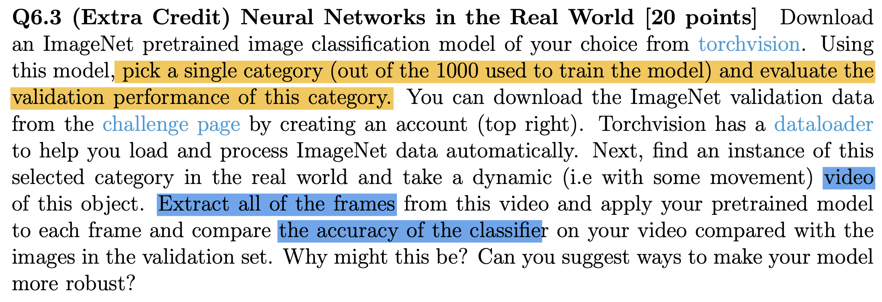

First, I tested ResNet50 pretrained on ImageNet dataset on a single validation image from the dataset whose category is ‘old English sheepdog’

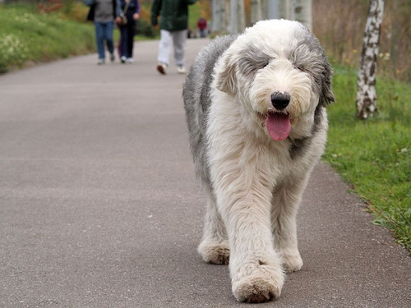

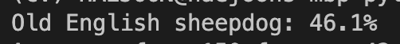

It successfully classified the image. Then, I download a video of English sheepdog, extracted 150 frames, and tested the model on them.

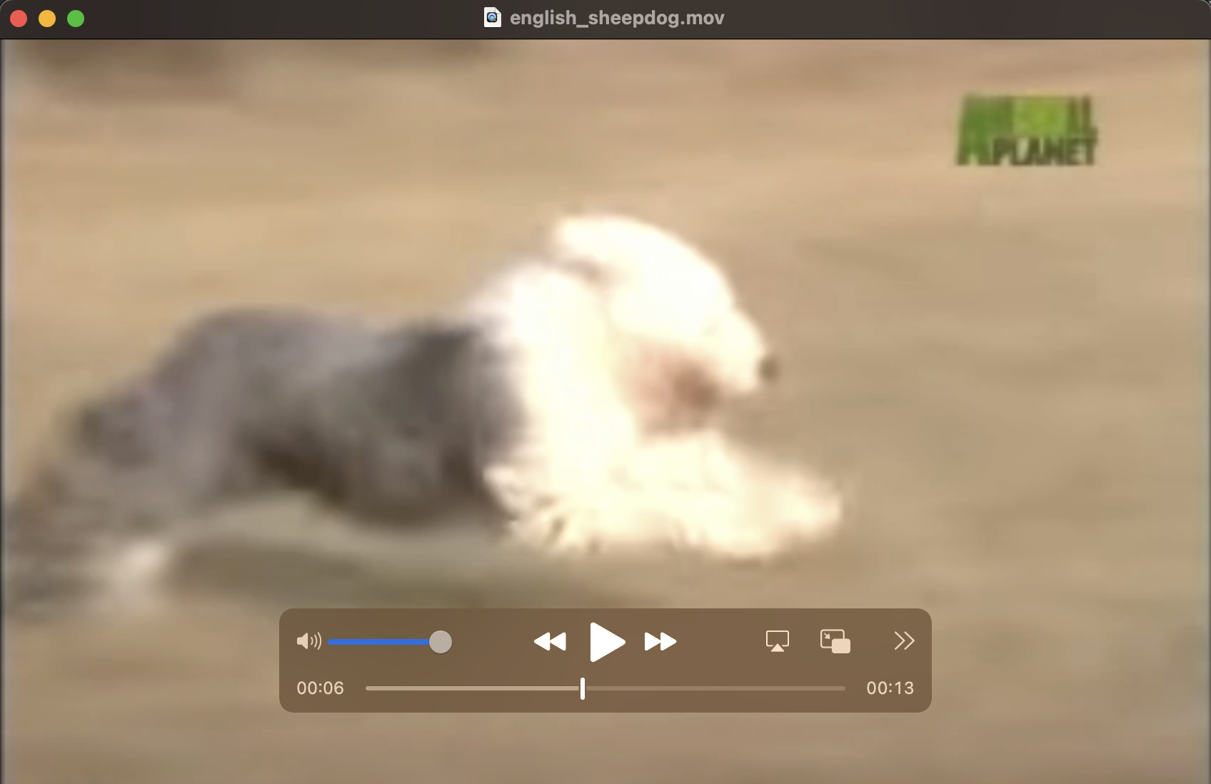



The total accuracy was 42%, which was much lower than the reported performance in the original paper. The reason will be the motion blur from moving and low resolution. If we have to test the 2D model on each video frame, deblurring process will be improve the performance.